**Ideation Phase**

**Define the Problem Statements**

| Date | 05 July 2025 |
| --- | --- |
| Team ID | LTVIP2025TMID35592 |
| Project Name | EduTutor AI: Personalized Learning With Generative AI And LMS Integration |
| Maximum Marks | 2 Marks |

🧩 Customer Problem Statement:

Modern educational institutions and e-learning platforms face major challenges in delivering personalized, scalable, and engaging learning experiences. Key areas such as curriculum customization, learner feedback, content creation, assessment, and progress tracking are often fragmented, time-consuming, and lack real-time adaptability. This results in disengaged learners, inconsistent learning outcomes, increased administrative burden, and reduced instructional effectiveness—especially when trying to adapt static content to diverse learner needs across LMS environments.

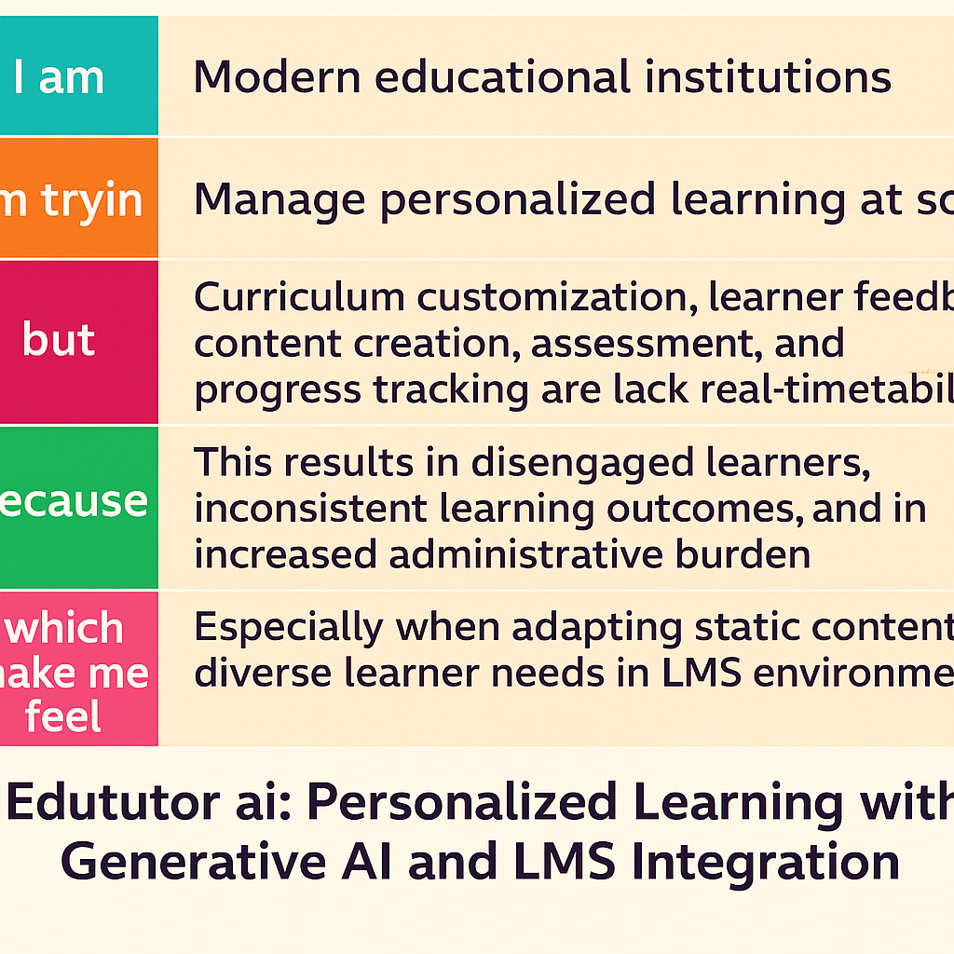

Reference::👉 [Using Edututor ai in personalized Learning – Scientific Diagram on ResearchGate](https://www.researchgate.net/figure/Using-SDLC-in-Development_fig2_318490613)

**Example:**

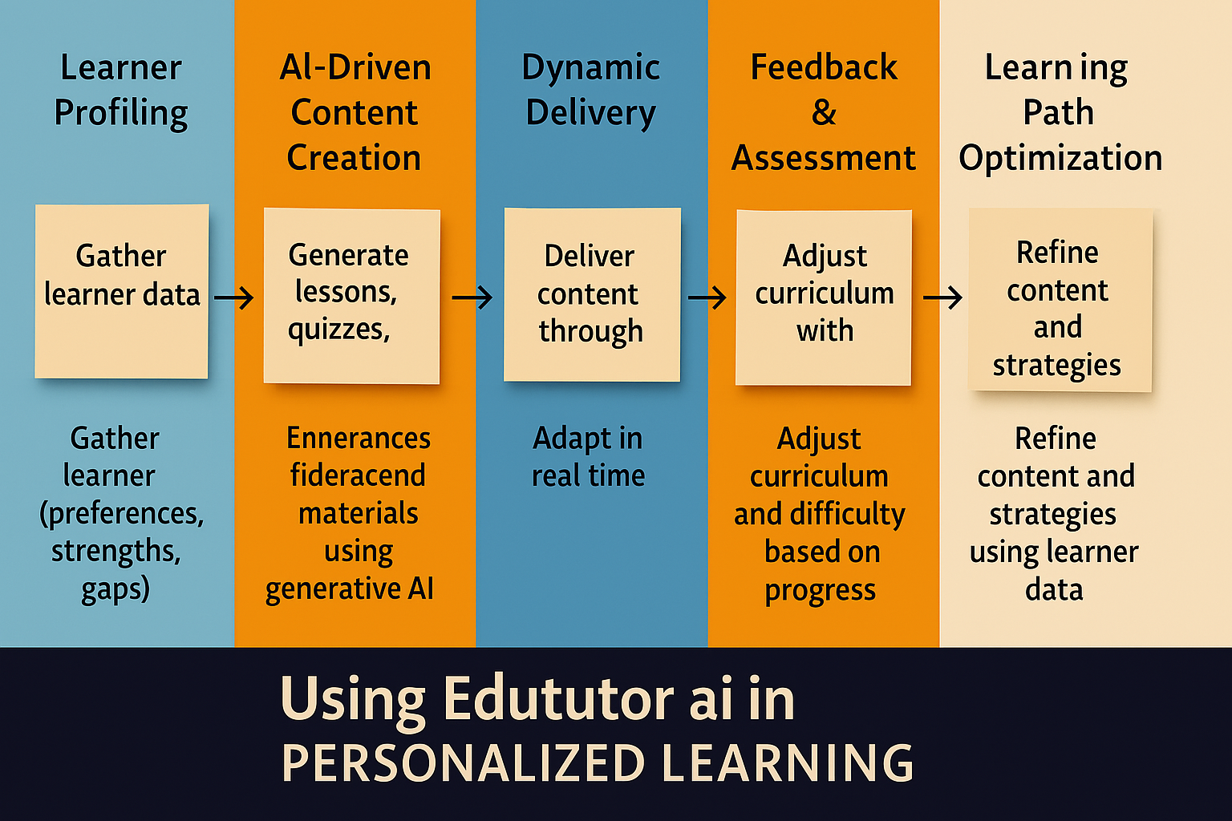

| **Problem Statement (PS)** | **I am (Modern Educational institution)** | **I’m trying to** | **But** | **Because** | **Which makes me feel** |
| --- | --- | --- | --- | --- | --- |
| Ps1 | A modern educational institution. | Provide personalized, engaging, and scalable learning experiences using cutting-edge technologies. | My current systems are fragmented, time-consuming, and lack intelligent automation. | Traditional LMS platforms don’t offer adaptive content delivery or real-time, AI-powered insights. | Inefficient, outdated, and unable to meet the evolving expectations of students and educators. |
| Ps2 | An online learning platform. | Deliver dynamic, AI-driven educational content that adapts to diverse learner needs. | Existing LMS tools are rigid, require manual intervention, and fail to personalize learning pathways | There is no seamless integration of generative AI within our learning ecosystem. | Underequipped to inspire meaningful learning outcomes at scale and stay competitive in the evolving edtech landscape. |